Changes to Markets
Practice graphing the following changes to markets. Begin drawing a graph that shows a market in equilibrium. Then show the appropriate changes to your graphs given the following situations. Be sure to state the effect on price of the changes to the involved market.

- There is a drought in California and no rain has fallen in two months! Many crops are devastated. What happens in the peach market?

- The price of books has increased greatly. What happens in the marketplace for books from the consumer point of view?

- The quantity supplied of comic books is much greater than the quantity demanded for comic books. What is occurring in the marketplace for comic books?

Changes to Markets Answer Key

There is a drought in California and no rain has fallen in two months! Many crops are devastated. What happens in the peach market?
S decreases. The S curve shifts to the left. The P of peaches goes up.
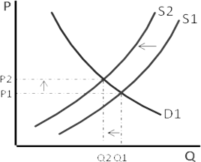
Peaches Graph:

- The price of books has increased greatly. What happens in the marketplace for books from the consumer point of view?
The P has changed which brings along a change in quantity demanded for books. We move along the demand curve back (up and left) to a lower quantity. Consumers will purchase a smaller quantity of books at a higher price.

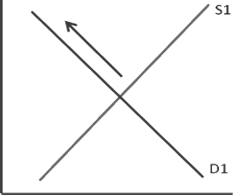
Books Graph:
P
P2 P1

Q2 Q1 Q

The quantity supplied of comic books is much greater than the quantity demanded for comic books. What is occurring in the marketplace for comic books?
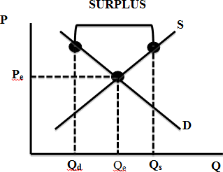
There is a surplus of comic books. The price must go down to equilibrium to reduce the surplus of comic books.

Comic Books Graph:

