Two States
(Oregon and Washington Additional Example)

Before trade, both states are self-sufficient in apples and timber and can produce at the levels shown below.

State Apples Timber Opp. Cost of 1 Opp. Cost of 1 Apple = Timber =
Oregon | 10 | 40 | .25 Apple | 4 Timber
Washington | 40 | 10 | 4 Apple | .25 Timber

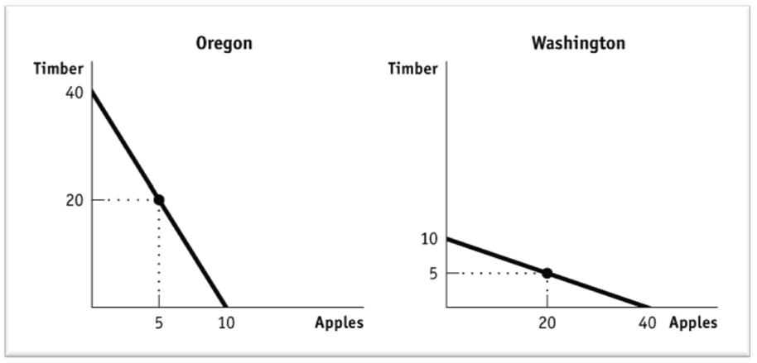
Note the absolute advantage that Oregon has in timber and Washington has in apple production. Draw these PPF’s. Assume each is producing (and consuming) at the midpoint.

So Oregon has 20 timber, 5 apples. Washington has 20 apples, 5 timber. Total timber production: 25 Total apple production: 25

How can these states increase output?
The principle of comparative advantage says that total output will be greatest when each good is produced by the state that has the lower opportunity cost.

Timber Apples
Oregon | 40 | 10
Washington | 10 | 40

Comparative advantage can be determined using the output method, which is used when output is variable and input is fixed. With the output method, apples go over timber and timber goes over apples as shown below. Remember OOO = Output Other Over.

Timber Apples
Oregon | 10 = .25  40 | 40 = 4  10
Washington | 40 = 4  10 | 10 = .25  40

Washington has comparative advantage in apple production because it has the lowest opportunity cost (0.25 of a unit of timber) and should specialize in apples.

Oregon should specialize in timber because of its comparative advantage. Its opportunity cost is only .25 of an apple while Washington must give up 4 apples to produce a unit of timber.

Note that if they specialize, they’ll produce (together) more apples and timber than they had individually without specialization.

In the PPC’s for each state, show the points of specialization.

Total timber production: 40 (all in Oregon) Total apple production: 40 (all in Washington)

So now Oregon doesn’t have anything to eat, and Washington doesn’t have any shelter. Maybe a trade is in order?

Oregon will export timber, Washington will export apples.

Comparative Advantage: Input & Output Supplemental Material

The AP® exam tests comparative advantage in two ways: as an output problem (the Oregon/Washington example) or as an input problem. The output method is used when output is variable and inputs are fixed. Students can remember how to do the math by using OOO = Output Other Over. The input method is used when inputs are variable and output is fixed. The input problem is sometimes confusing for the students, so present this example so that they are familiar with it on exam day. You can remember how to do the math by using IOU = Input Other Under.

Note: when giving the students the table below, leave the last two columns empty.
Students are presented with a problem that describes two towns and how many hours (the input) that it takes to produce each product. Suppose:

Hours to produce Hours to produce Producing 1 unit Producing 1 unit 1 unit of Donuts 1 unit of Coffee of donuts costs of coffee costs
Springfield | 8 | 4
Shelbyville | 24 | 8

With the input method, coffee production goes under donut production and donut production goes under coffee production. (IOU)

Springfield has an absolute advantage producing both donuts and coffee because it takes them fewer hours. Why would Springfield want to trade if they can do more of both?

Hours to produce Hours to produce Producing 1 unit Producing 1 unit 1 unit of Donuts 1 unit of Coffee Of donuts costs of coffee costs
Springfield | 8 = 2  4 | 4 = .5  8 | 2 unit of coffee | ½ unit of donuts
Shelbyville | 24 = 3  8 | 8 = .33  24 | 3 units of coffee | 1/3 unit of donuts

Every unit of donuts Springfield produces requires them to give up 8 hours in which they could have made 2 units of coffee. Thus in Springfield, 1 donut = 2 coffee.

In Shelbyville, each unit of donuts requires them to give up 24 hours in which they could have produced 3 units of coffee. So, in Shelbyville, 1 donut = 3 coffee.

Springfield therefore has a comparative advantage producing donuts.
Shelbyville has a comparative advantage in producing coffee, because to produce one coffee they give up
⅓ of a unit of donuts, while Springfield must give up ½ of a unit of donuts.

