Comparative Advantage

There are two nations that, using all of their resources, both produce lemon drops and boxes. Nation A can produce either 300 lemon drops and 0 boxes per day or 100 boxes and 0 lemon drops per day or any combination that lies on its constant cost PPC. Nation B can produce either 200 lemon drops and 0 boxes per day or 200 boxes and 0 lemon drops per day or any combination that lies on its constant cost PPC.

Draw a correctly labeled PPC for each nation. Use lemon drops on the vertical axis and boxes on the horizontal axis.

Calculate the opportunity cost of producing each good for each nation. (Calculate means show your work.)

 | Lemon Drops | Boxes | Opportunity cost of Lemon Drops | Opportunity cost of Boxes
Nation A
Nation B

What good should each nation specialize in? Why?

What range would be acceptable terms of trade? Why?

The U.S. and England have the following production possibility curves.
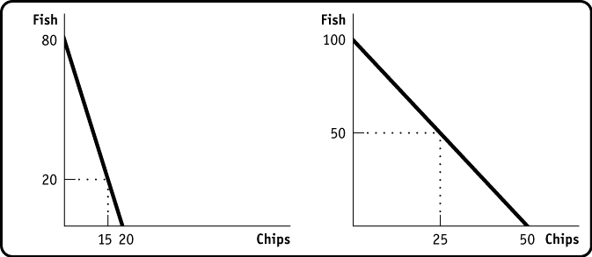
United States England

Using the information on the graphs above:

The opportunity cost of 1 unit of Fish in the U.S. is . The opportunity cost of 1 unit of Chips in the U.S. is . The opportunity cost of 1 unit of Fish in England is . The opportunity cost of 1 unit of Chips in England is . The U.S. has an absolute advantage in .
England has an absolute advantage in . The U.S. has a comparative advantage in . England has a comparative advantage in .

Fill in the table below.
Without Trade With Trade (production)

With Trade (consumption)

Chips Fish Chips Fish Chips Fish
United States
England

Total

Note: Assume that with trade, each country exports ½ of its production. What happens to total world output when the countries specialize and trade?

Are the countries better off? Explain.

There are two nations that both produce 100 lemon drops and 50 boxes using the same amount of resources. Nation A can produce lemon drops in 3 hours and boxes in 2 hours. Nation B can produce lemon drops in 4 hours and boxes in 5 hours.

Calculate the opportunity cost of producing each good for each nation. (Calculate means show your work.)

 | Lemon Drops | Boxes | Opportunity cost of Lemon Drops | Opportunity cost of Boxes
Nation A
Nation B

What good should each nation specialize in? Why? What range would be acceptable terms of trade? Why?

Comparative Advantage Answer Key
There are two nations that both produce lemon drops and boxes using all of their resources. Nation A can produce either 300 lemon drops and 0 boxes per day or 100 boxes and 0 lemon drops per day or any combination that lies on its constant cost PPC. Nation B can produce either 200 lemon drops and 0 boxes per day or 200 boxes and 0 lemon drops per day or any combination that lies on its constant cost PPC.

Draw a correctly labeled PPC for each nation.

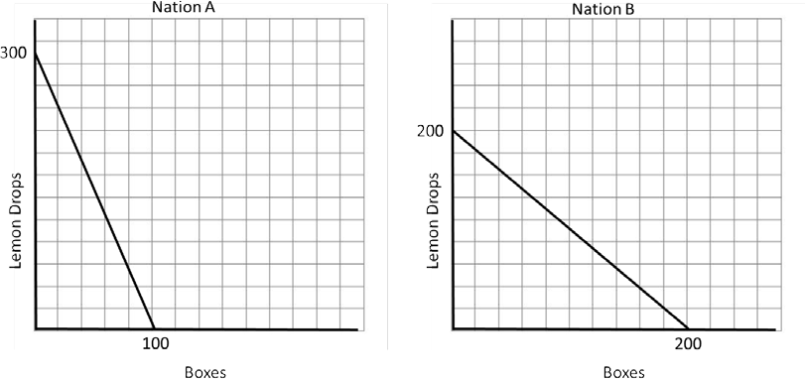

Calculate the opportunity cost of producing each good for each nation. (Calculate means show your work.)

 | Lemon Drops | Boxes | Opportunity cost of Lemon Drops | Opportunity cost of Boxes
Nation A | 100  300 | 300  100 | ⅓ | 3
Nation B | 200  200 | 200  200 | 1 | 1

What good should each nation specialize in?
- Nation A should specialize in lemon drops because they have the lowest opportunity cost. They only give up ⅓ lemon drops to produce 1 box while Nation B gives up 1 lemon drop to produce 1 box.
- Nation B should specialize in boxes because they have the lowest opportunity cost. They only give up 1 box to produce 1 lemon drop while Nation A gives up 3 boxes to produce 1 lemon drop.

What range would be acceptable terms of trade?
Lemon Drops: between .33 and 1 because Nation A wants more than its opportunity cost of ⅓
box, and Nation B wants to give less than its opportunity cost of 1 box.
Boxes: between 1 and 3 because Nation B wants more than its opportunity cost of 1 lemon drop, and Nation A wants to give less than its opportunity cost of 3 boxes.

The U.S. and England have the following production possibility curves.
United States England

Using the information on the graphs above:

The opportunity cost of 1 unit of Fish in the U.S. is ¼ chips.

The opportunity cost of 1 unit of Chips in the U.S. is 4 fish.

The opportunity cost of 1 unit of Fish in England is ½ chips.

The opportunity cost of 1 unit of Chips in England is 2 fish.

The U.S. has an absolute advantage in neither good.

England has an absolute advantage in both goods.

The U.S. has a comparative advantage in fish.

England has a comparative advantage in chips.

Fill in the table below.
Without Trade With Trade (production)

With Trade (consumption)

Chips | Fish |  | Chips | Fish |  | Chips | Fish
England 25 | 50 |  | 50 | 0 |  | 25 | 40
United 15  States | 20 |  | 0 | 80 |  | 25 | 40
Total 40 | 70 |  | 50 | 80 |  | 50 | 80

Note: Assume that with trade, each country exports ½ of its production.

What happens to total world output when the countries specialize and trade? There is more of each product produced.

Are the countries better off? Explain. The United States is better off as it now has more of both products. England is not better off. It has the same amount of chips but fewer fish than before.

There are two nations that both produce 100 lemon drops and 50 boxes using the same amount of resources. Nation A can produce lemon drops in 3 hours and boxes 2 hours. Nation B can lemon drops in 4 hours and boxes 5 hours.
Calculate the opportunity cost of producing each good for each nation. (Calculate means show your work.)

 | Lemon Drops | Boxes | Opportunity cost of Lemon Drops | Opportunity cost of Boxes
Nation A | 3  2 | 2  3 | 1.5 | .67
Nation B | 4  5 | 5  4 | .8 | 1.25

What good should each nation specialize in? Why?
- Nation A should specialize in boxes because they have the lowest opportunity cost.
- Nation B should specialize in lemon drops because they have the lowest opportunity cost.

What range would be acceptable terms of trade? Why?
Lemon Drops: between .8 and 1.5
Boxes: between .67 and 1.25

Using these terms of trade will allow both nations to benefit as the opportunity cost with trade is less than the opportunity cost to produce the good without trade.

