**Gummy Bear Government**

|  |
| --- |
| **Warm-up:** Review our *Types of Government”* handout. Which of these forms of government, other than democracy, do you believe is the most effective? Why? (Do not pick democracy) |
|  |

**Task**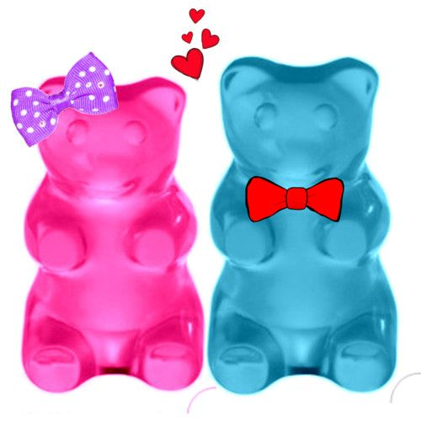

* Get into groups of three
* Use Gummy Bears and any other props available to create models of the forms of government that we have studied
* Take pictures of each of the models before you take them apart
* Create a photo essay of your models and upload them to Google Slides Presentation
* Share your presentation with your group so that you can all work on the project together
* In the presentation you can use the writing tools, labels, draw extra images, explain, etc.



**Each slide needs…**

1. Image of the gummy bear government
2. Title (the type of government)
3. Explanation of how the photo represents that form of government
4. At least one example of a country/region that has/had that type of government
   1. Cannot be the example we used in class
5. The name of the student(s) that created the slide
   1. If a member of your group decides not to work or do their fair share, do not write their name
   2. This will be an individual grade
6. Include a description of what or who gives this type of government **legitimacy**

**Government List**

|  |  |  |
| --- | --- | --- |
| * **Monarchy** * **Oligarchy** * **Dictatorship** * **Communism** | * **Theocracy** * **Military Junta** * **Fascism** | * **Anarchy (Absence of any government)** * **Democracy** * **Socialism** |