Effects of Expansionary Monetary Policy

- Draw an AD-AS graph showing long-run equilibrium.

- Draw a money market graph. Show and explain how expansionary monetary policy would impact interest rates?

- Using the graph in part 1, show how the change in interest rates would affect the AD/AS model. Explain.

- Explain how real GDP and price level would be affected by the change in interest rates in the short-run.

- Using your graph in part 1, show how SRAS will be impacted the change in interest rates in the long-run? Explain.

Effects of Expansionary Monetary Policy Answer Key
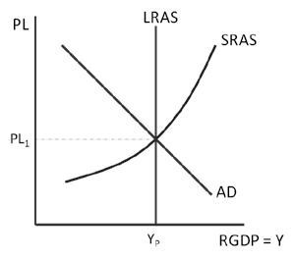
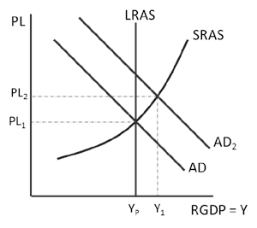
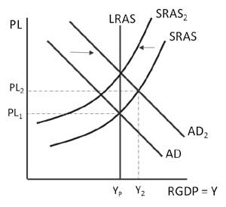
- Draw an AD-AS graph showing long-run equilibrium. (Graph show at each stage, question 1, 3, and 5)
Question 1 Graph Question 3 Graph Question 5 Graph

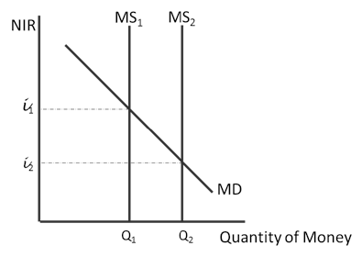
- Draw a money market graph. Show and explain how expansionary monetary policy would impact interest rates?
If the Fed were to conduct expansionary monetary policy, the interest rate would fall.

- Using the graph in part 1, show how the change in interest rates would affect the AD/AS model. Explain.

A lower interest rate would increase investment and interest sensitive consumer spending and shift AD to the right.

- Explain how real GDP and price level would be affected by the change in interest rates in the short-run.

In the short run, real GDP would increase, but so would the aggregate price level.

- Using your graph in part 1, show how SRAS will be impacted the change in interest rates in the long-run? Explain.

Eventually nominal wages would rise in labor markets, shifting SRAS to the left.

