Equilibrium

Use AD/AS graphs to show the short-run effects of each of the following shocks on the aggregate price level and on aggregate output.

  - The price of copper, steel, and other commodities has risen in global markets.
  - A weak auto industry has prompted less investment spending by many firms that manufacture auto parts (brake pads, fan belts, spark plugs, etc).
  - Congress lowers taxes and increases spending.
  - More and more students are graduating from high school and receiving college degrees.
  - The average wage rises way above inflation for the first quarter of the year.
  - Newspapers report housing sales have decreased for the third month in a row.

- Draw a graph that shows the economy currently in long-run equilibrium.

  - Suppose that household wealth has been falling for several months. Given this, adjust your graph to show both the short-run change in price level and real GDP.
  - Describe how the economy will adjust in the long run. Using the graph you drew in part a, show this adjustment to long-run equilibrium.

Equilibrium Answer Key

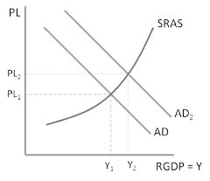
Use AD/AS graphs to show the short-run effects of each of the following shocks on the aggregate price level and on aggregate output.

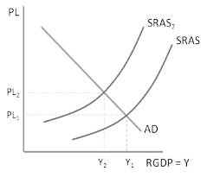
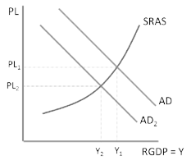
a. b. c.

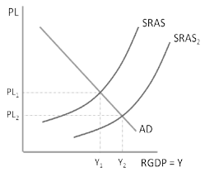
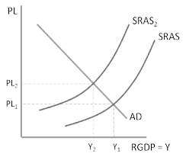
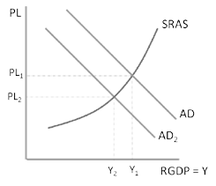
d.

e. f.

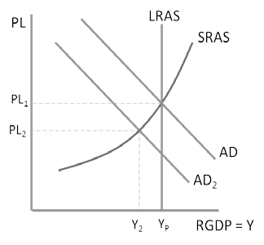
- Draw a graph that shows the economy currently in long-run equilibrium. Describe how the economy will adjust in the long run. Using the graph you drew in part a, show this adjustment to long-run equilibrium.

a.

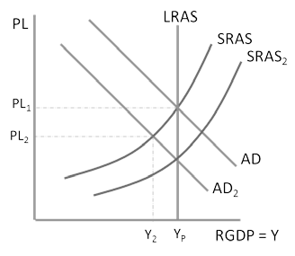
b.
A recessionary gap in the short implies that there is high unemployment. In the short run wages are sticky so nothing happens.
However, in the LR wages fall. This lowers firms’ cost of production and therefore they can supply a higher output at the same price. This is shown in the rightward shift of the SRAS. The SRAS keeps shifting right to bring the economy back to the full employment equilibrium.

