Exchange Rate Policy

Write the answer to this question in blue or black ink on a separate sheet of paper. This question would be worth 11 points.

Suppose the United States and China were the only two countries in the world.
  - Draw a correctly labeled graph of the foreign exchange market for U.S. dollars showing the equilibrium in the market. The currency in China is the yuan.

  - On the graph you drew in part a, indicate a fixed exchange rate set below the equilibrium exchange rate. Does the fixed exchange rate lead to a surplus or shortage of U.S. dollars? Explain and show the amount of the surplus/shortage on your graph.

  - To bring the foreign exchange market back to equilibrium at the fixed exchange rate, would the U.S. government need to buy or sell dollars? On the graph you drew in part a, illustrate how the government buying or selling dollars would bring the equilibrium exchange rate back to the desired fixed rate.

  - Suppose that instead of buying or selling dollars, the Federal Reserve was going to engage in monetary policy to bring the foreign exchange market back to equilibrium at the fixed exchange rate. Should the Fed buy or sell Treasury securities in an open-market operation? Explain.

Exchange Rate Policy Answer Key

Write the answer to this question in blue or black ink on a separate sheet of paper. This question would be worth 11 points.

Suppose the United States and China were the only two countries in the world.
- Draw a correctly labeled graph of the foreign exchange market for U.S. dollars showing the equilibrium in the market. The currency in China is the yuan.
See graph below.
- On the graph you drew in part a, indicate a fixed exchange rate set below the equilibrium exchange rate. Does the fixed exchange rate lead to a surplus or shortage of U.S. dollars? Explain and show the amount of the surplus/shortage on your graph.
See graph below for indication of fixed exchange rate. Shortage. The quantity demanded exceeds the quantity supplied at the higher fixed exchange rate.
- To bring the foreign exchange market back to equilibrium at the fixed exchange rate, would the U.S. government need to buy or sell dollars? On the graph you drew in part a, illustrate how the government buying or selling dollars would bring the equilibrium exchange rate back to the desired fixed rate.
The government will sell dollars in the foreign exchange market. See graph below for indication of government action.
- Suppose that instead of buying or selling dollars, the Federal Reserve was going to engage in monetary policy to bring the foreign exchange market back to equilibrium at the fixed exchange rate. Should the Fed buy or sell Treasury securities in an open-market operation? Explain.
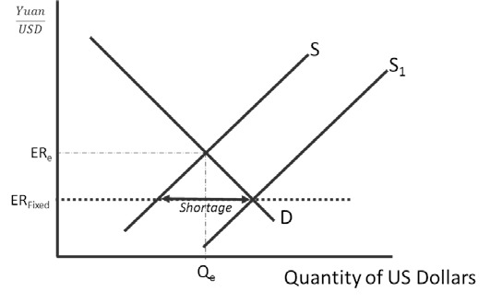
The Fed should buy Treasury securities to reduce interest rates. The reduction in interest rates will decrease demand for the U. S. dollar causing the price of the dollar to fall.

Teaching Note: Use this scoring scheme below if you want to simulate a FRQ found on the AP Exam.

(1 point) The vertical axis is labeled “^{𝑌𝑢𝑎𝑛}”and the horizontal axis is labeled “Quantity of U.S.
𝑈𝑆𝐷
dollars.”
(1 point) Demand is downward sloping and labeled, supply is upward sloping and labeled.
(1 point) The equilibrium exchange rate and the quantity of dollars are labeled on the axes at the point where the supply and demand curves intersect.
(1 point) The fixed exchange rate level is depicted below the equilibrium exchange rate. (1 point) Shortage
(1 point) The quantity demanded exceeds the quantity supplied at the higher fixed exchange rate. (1 point) The shortage is labeled as the horizontal distance between the supply and demand
curves at the fixed exchange rate. (1 point) Sell
(1 point) The new supply curve is shown to the right of the old supply curve, crossing the demand curve at the fixed exchange rate.
(1 point) Buy Treasuries
(1 point) Expansion of the money supply decreases interest rates in the U.S. This will reduce the demand for the dollar and increase the supply of the dollar. The price of the dollar will begin to fall.

