Financial Flows

For each of the following scenarios, draw a correctly labeled loanable funds graph for each nation and explain the direction of financial capital between the nations. Then determine which nation will have a higher rate of investment in physical capital.

- The real interest rate in France is 5% while the real interest rate in the United States is 2%.

- The real interest rate in Scotland is 6% while the real interest rate in the United States is 8%.

Financial Flows Answer Key

For each of the following scenarios, draw a correctly labeled loanable funds graph for each nation and explain the direction of financial capital between the nations. Then determine which nation will have a higher rate of investment in physical capital.
- The real interest rate in France is 5% while the real interest rate in the United States is 2%.
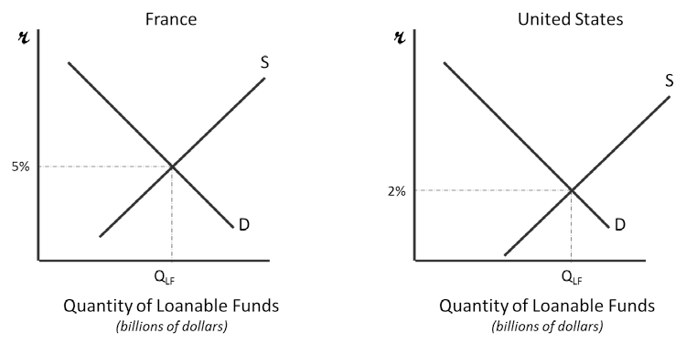
Financial capital will flow from the United States to France because the interest rates are higher. There will be more investment in physical capital in the United States because lower interest rates attract borrowers. The interest rate should settle to an equilibrium rate of 3½%.

- The real interest rate in Scotland is 6% while the real interest rate in the United States is 8%.
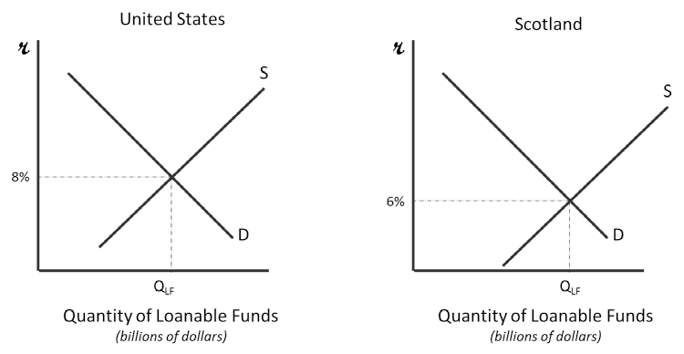

Financial capital will flow from the Scotland to the United States because the interest rates are higher. There will be more investment in physical capital in Scotland because lower interest rates attract borrowers. The interest rate should settle to an equilibrium rate of 7%.

