Fiscal Policy

The economy is currently experiencing a recessionary gap. List two fiscal policy options that would move the economy closer to potential real GDP. Using a correctly labeled AD/AS graph and then explain how your policy would achieve the desired result. Make sure to explain what will happen to output and price level.

Policy options:
Explanation

- The economy is currently at a level of output that exceeds potential GDP (Yp). List two fiscal policy options that would move the economy closer to potential real GDP. Show and explain how your policy would achieve the desired result. Make sure to explain what will happen to output and price level.

Policy options:
Explanation

Fiscal Policy Answer Key

The economy is currently experiencing a recessionary gap. List two fiscal policy options that would move the economy closer to potential real GDP. Show and explain how your policy would achieve the desired result. Make sure to explain what will happen to output and price level.

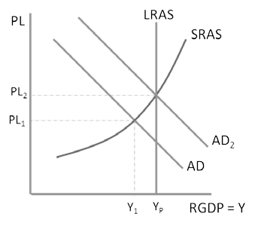
Policy: increase G, increase transfer payments, or decrease taxes.
Explanation: An increase in G will directly affect AD and shift it to the right, increasing real GDP.
An increase in transfers or decrease in taxes will indirectly increase AD by increasing disposable income and consumer spending. Real GDP would rise and the price level will rise as well.

- The economy is currently at a level of output that exceeds potential GDP (Yp). List two fiscal policy options that would move the economy closer to potential real GDP. Show and explain how your policy would achieve the desired result. Make sure to explain what will happen to output and price level.

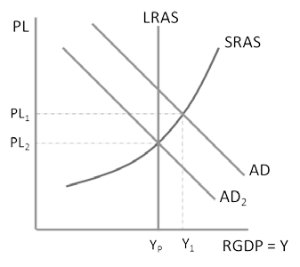
Policy: decrease G, decrease transfer payments, or increase taxes.
Explanation: A decrease in G will shift AD to the left, decreasing real GDP, and reducing the price level. A decrease in transfers or increase in taxes will indirectly decrease AD by decreasing disposable income and therefore consumer spending. Real GDP would fall and the price level would fall.

