Fiscal Policy and the Multiplier

Use your knowledge of multipliers and fiscal policy to answer each of the following questions.

- Real GDP is currently $600 billion above potential GDP and price inflation is beginning to dominate the headlines. Draw a correctly labeled AD/AS graph to show the problem in the economy. How could the government adjust taxes or transfers to return the economy to full employment? Assume the MPC=.75. How large would this lump-sum adjustment need to be? Show the impact of the policy on output and price level on the graph you drew previously.

- Current real GDP is $6 trillion and potential GDP is $7.5 trillion. Draw a correctly labeled AD/AS graph to show the problem in the economy. The government is prepared to pass a spending package to return the economy to full employment. What kind of spending package should be passed and how big does it need to be? Assume that the MPC = .90. Show the impact of the policy on output and price level on the graph you drew previously.

Fiscal Policy and the Multiplier Answer Key

Use your knowledge of multipliers and fiscal policy to answer each of the following questions.

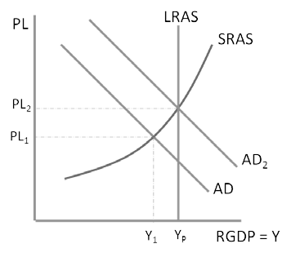
- Real GDP is currently $600 billion above potential GDP and price inflation is beginning to dominate the headlines. Draw a correctly labeled AD/AS graph to show the problem in the economy. How could the government adjust taxes or transfers to return the economy to full employment? Assume the MPC=.75. How large would this lump-sum adjustment need to be? Show the impact of the policy on output and price level on the graph you drew previously.

Answer: Because the economy is suffering from inflation, taxes need to be raised or transfers need to

be cut. The tax multiplier Tm = ^{.75}
(1−.75)
= 3. To

reduce real GDP by $600 billion, taxes need to be increased (or transfers need to be decreased) by
$600 𝑏𝑖𝑙𝑙𝑖𝑜𝑛 = $200 billion.
3

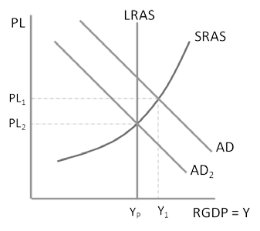
- Current real GDP is $6 trillion and potential GDP is $7.5 trillion. Draw a correctly labeled AD/AS graph to show the problem in the economy. The government is prepared to pass a spending package to return the economy to full employment. What kind of spending package should be passed and how big does it need to be? Assume that the MPC = .90. Show the impact of the policy on output and price level on the graph you drew previously.

Answer: The economy is in a recession so spending must be increased with expansionary fiscal policy. The

spending multiplier M = ¹
(1−.90)
= 10. To increase real

GDP by $1.5 trillion, government spending needs to be
increased by ^{$1.5} ^{𝑡𝑟𝑖𝑙𝑙𝑖𝑜𝑛} = $.15 trillion or $150 billion.
10

