Graphing Exchange Rates

In each of the scenarios below, correctly draw and label the exchange rate graph for each nation. Then indicate the impact of each scenario on each nation’s currency.

- Real interest rates rise faster in Scotland (British Pound) than they do in the United States (USD).

  - Rationale:

  - Which nation’s currency appreciates?

  - Which nation’s currency depreciates?

  - How will the change in the value of the U.S. Dollar impact the balance of trade in the United States?

  - How will the change in the value of the British Pound impact the balance of trade in Scotland?

- Americans (USD) go crazy for scarves made in Brazil (real).

  - Rationale:

  - Which nation’s currency appreciates?

  - Which nation’s currency depreciates?

  - How will the change in the value of the U.S. Dollar impact the balance of trade in the United States?

  - How will the change in the value of the Brazilian real impact the balance of trade in Brazil?

- Prices rise faster in France (euro) than they do in the United States (USD).

  - Rationale:

  - Which nation’s currency appreciates?

  - Which nation’s currency depreciates?

  - How will the change in the value of the U.S. Dollar impact the balance of trade in the United States?

  - How will the change in the value of the euro impact the balance of trade in France?

- Income rises at a slower rate in Mexico than it does in the United States (USD).

  - Rationale:

  - Which nation’s currency appreciates?

  - Which nation’s currency depreciates?

  - How will the change in the value of the U.S. Dollar impact the balance of trade in the United States?

  - How will the change in the value of the peso impact the balance of trade in Mexico?

Graphing Exchange Rates Answer Key

In each of the scenarios below, correctly draw and label the exchange rate graph for each nation. Then indicate the impact of each scenario on each nation’s currency.

    - Real interest rates rise faster in Scotland (British Pound) than they do in the United States (USD).
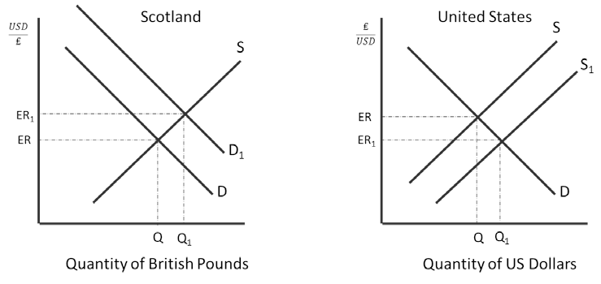

      - Rationale: Because real interest rates are higher in Scotland, Americans will supply more dollars to the market to buy pounds so they can invest in Scottish financial assets.

      - Which nation’s currency appreciates? The British Pound

      - Which nation’s currency depreciates? The U.S. Dollar

      - How will the change in the value of the U.S. Dollar impact the balance of trade in the United States? When the dollar depreciates, that makes U.S. goods look less expensive for Scots to buy so exports increase and imports decrease because they are now more expensive for Americans to buy. The nation experiences a trade surplus.

      - How will the change in the value of the British Pound impact the balance of trade in Scotland? When the pound appreciates, that makes Scottish goods look more expensive for Americans to buy so exports decrease and imports increase because they are now less expensive for Scots to buy. The nation experiences a trade deficit.

    - Americans (USD) go crazy for scarves made in Brazil (real).
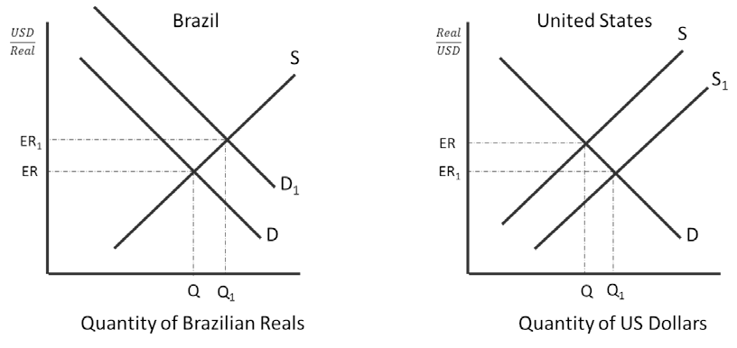

      - Rationale: Because Americans want goods made in Brazil, Americans will supply more dollars to the market to buy reals so they can buy the scarves.

      - Which nation’s currency appreciates? The Brazilian Real

      - Which nation’s currency depreciates? The U.S. Dollar

      - How will the change in the value of the U.S. Dollar impact the balance of trade in the United States? When the dollar depreciates, that makes U.S. goods look less expensive for Brazilians to buy so exports increase and imports decrease because they are now more expensive for Americans to buy. The nation experiences a trade surplus.

      - How will the change in the value of the Brazilian Real impact the balance of trade in Brazil? When the real appreciates, that makes Brazilian goods look more expensive for Americans to buy so exports decrease and imports increase because they are now less expensive for Brazilians to buy. The nation experiences a trade deficit.

    - Prices rise faster in France (euro) than they do in the United States (USD).
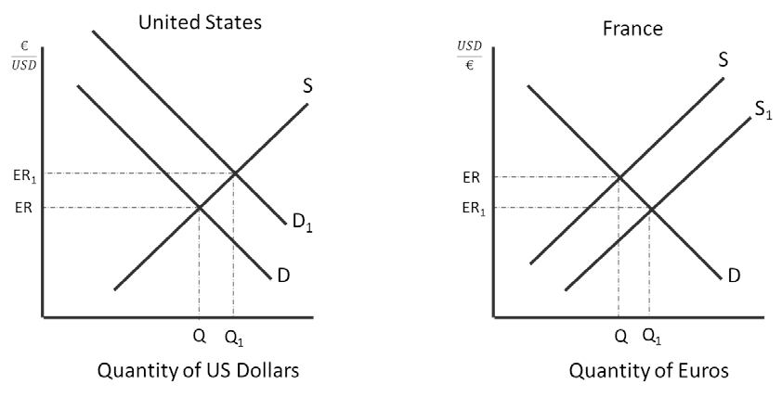

      - Rationale: Because prices are higher in France, the French will supply more dollars to the market to buy U.S. dollars so they can buy cheaper American goods.

      - Which nation’s currency appreciates? The U.S. Dollar

      - Which nation’s currency depreciates? The Euro

      - How will the change in the value of the U.S. Dollar impact the balance of trade in the United States? When the U.S. dollar appreciates, that makes American goods look more expensive for the French to buy so exports decrease and imports increase because they are now less expensive for Americans to buy. The nation experiences a trade deficit.

      - How will the change in the value of the British Pound impact the balance of trade in Scotland? When the euro depreciates, that makes French goods look less expensive for Americans to buy so exports increase and imports decrease because they are now more expensive for the French to buy. The nation experiences a trade surplus.

    - Income rises at a slower rate in Mexico than it does in the United States (USD).
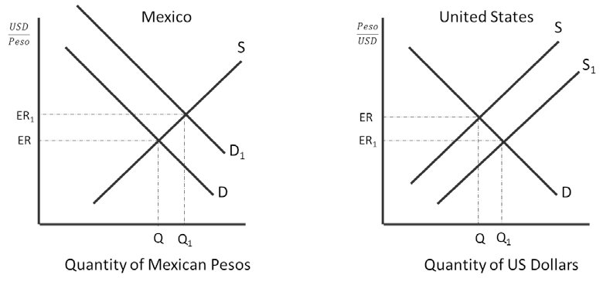

      - Rationale: Because Americans have more income that citizens of Mexico, Americans will supply more dollars to the market to buy pesos so they can buy cheaper Mexican goods.

      - Which nation’s currency appreciates? The Mexican Peso

      - Which nation’s currency depreciates? The U.S. Dollar

      - How will the change in the value of the U.S. Dollar impact the balance of trade in the United States? When the dollar depreciates, that makes U.S. goods look less expensive for Mexicans to buy so exports increase and imports decrease because they are now more expensive for Americans to buy. The nation experiences a trade surplus.

      - How will the change in the value of the Mexican Peso impact the balance of trade in Mexico? When the real appreciates, that makes Mexican goods look more expensive for Americans to buy so exports decrease and imports increase because they are now less expensive for Mexicans to buy. The nation experiences a trade deficit.

