Interest Rates in the Long Run

- Draw a money market graph showing equilibrium interest rate (r1) and equilibrium quantity (QM₁).

- Using the money market graph you drew in question 1, show and explain what will happen to equilibrium interest rate if the money supply increases by 10%?

- According to money neutrality, how will this change in the money supply impact the long run aggregate price level?

- Using the money market graph you drew in question 1, show and explain why the price level you identified in question 3 will impact the money market.

Interest Rates in the Long Run Answer Key

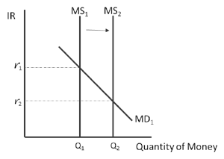
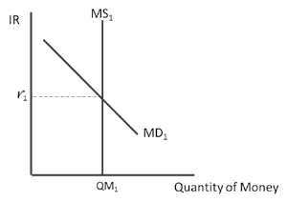
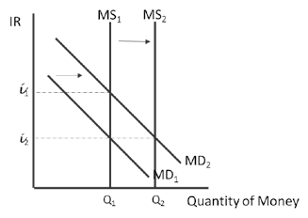
  - Draw a money market graph showing equilibrium interest rate (r1) and equilibrium quantity (QM₁).
Question 1 Graph Question 2 Graph Question 4 Graph

  - Using the money market graph you drew in question 1, show and explain what will happen to equilibrium interest rate if the money supply increases by 10%?

If the money supply increases by 10%, the short-run interest rate falls.

  - According to money neutrality, how will this change in the money supply impact the long run aggregate price level?

According to money neutrality, the aggregate price level rises by 10% in the long-run.

  - Using the money market graph you drew in question 1, show and explain why the price level you identified in question 3 will impact the money market.

When aggregate prices rise by 10%, households will increase their demand for money by 10%. When money supply and demand shift to the right by 10%, the long-run equilibrium interest rate returns to r1.

