Market Changes in Demand

Practice your graph skills with this worksheet. You will be given several different scenarios that occur to a market that was in equilibrium before this scenario occurred. Follow these instructions:
  - Graph the new situation so that it shows the change that occurred.
  - Circle where indicated whether there has been a change in demand, or a change in quantity demanded.
  - Be sure to show the new equilibrium price and quantity points on your graph.
  - Provide the explanation for the change.

Here are your scenarios:
- The price of peaches is $2.29 per pound on Monday. On Thursday, the price of peaches goes to $2.79 per pound.

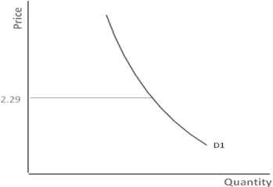
Peaches Graph:

What changes: D or Q_{d}?

- The incomes of the city of Downville have decreased by 20% due to the closing of a large factory. What happens in the peach market in the local grocery store?

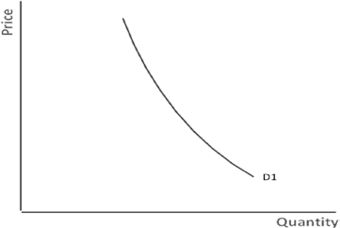
Peaches Graph:

What changes? D or Q_{d}?

- Suppose The American Heart
Association declares that peaches promote good heart health.

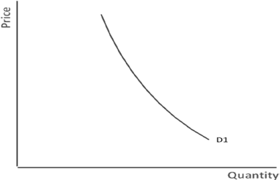
Peaches Graph:
What changes: D, or Q_{d}?

- You and your friends expect that the ability to download songs from the internet for free will end in 3 months, and then downloads will be for purchase only. Show what happens in the market tomorrow!

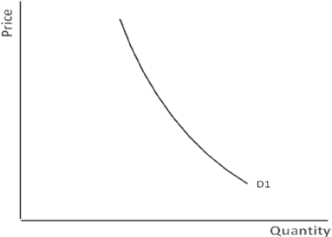
Downloaded Songs Graph:

- The price of popcorn goes from $5 a bag to $3 a bag.

Popcorn Graph:
What changes: D or Q_{d}?

What changes: D or Q_{d}?

- Now show the changes that occur in the apple market given the following: Peaches and apples are substitutes. The price of apples increases.

Peaches Graph:
What changes: D or Q_{d}?

Market Changes in Demand Answer Key

Practice your graph skills with this worksheet. You will be given several different scenarios that occur to a market that was in equilibrium before this scenario occurred. Follow these instructions:
- Graph the new situation so that it shows the change that occurred.
- Circle where indicated whether there has been a change in demand or a change in quantity demanded.
- Be sure to show the new equilibrium price and quantity points on your graph.
- Provide the explanation for the change.

Here are your scenarios:
- The price of peaches is $2.29 per pound on Monday. On Thursday, the price of peaches goes to $2.79 per pound.

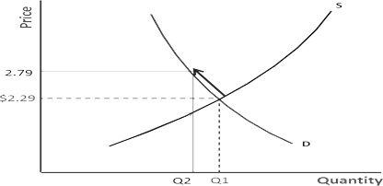
Peaches Graph:
What changes: D or Q_{d}? Q_{d}

1d. An increase in price causes a decrease in quantity demanded.

- The incomes of the city of Downville have decreased by 20% due to the closing of a large factory. What happens in the peach market in the local grocery store?

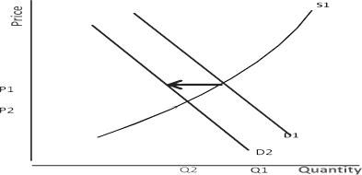
Peaches Graph:

What changes? D or Q_{d}? D

2d. Decrease in income causes a decrease in demand for peaches.

- Suppose The American Heart Association declares that peaches promote good heart health.

Peaches Graph:
What changes: D or Q_{d}? D

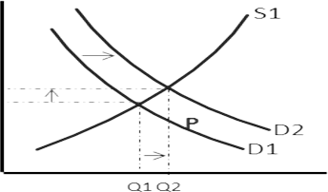
3d. Due to people preferring healthy lifestyles there is an increase in demand for peaches.

- You and your friends expect that the ability to download songs from the internet for free will end in 3 months, and then it downloads will be for purchase only.
Downloaded

Songs Graph:
What changes: D or Q_{d}? D

4d. Since you are expecting prices to rise for songs in 3 months, demand for songs will increase now since it is free.

- The price of popcorn goes from $5 a bag to $3 a bag.

Popcorn Graph:
What changes: D or Q_{d}? Q_{d}

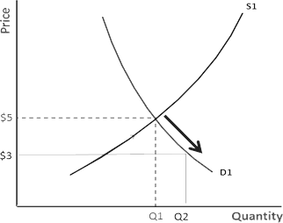
5d. A decrease in the price of the popcorn causes an increase in quantity demanded for popcorn.

- Now show the changes that occur given the following: Peaches and apples are substitutes. The price of apples increases.
Peaches Graph:
What changes: D or Q_{d}? D 6d. An increase in the price of
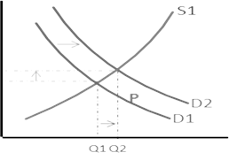
the substitute, apples, will cause
an increase in demand for peaches.

