Market Changes in Supply
Practice your graph skills with this worksheet. You will be given several different scenarios that occur to a market that was in equilibrium before this scenario occurred.
- Graph the new situation so that it shows the change that occurred.
- Circle where indicated whether there has been a change in supply, or a change in quantity supplied.
- Be sure to show the new equilibrium price and quantity points on your graph.
- Explain the reason for the change.

Here are your scenarios:

- The cost of the eggs and milk used to make cakes at the local bakery increases. What happens in the bakery market for cakes?

Cakes Graph:

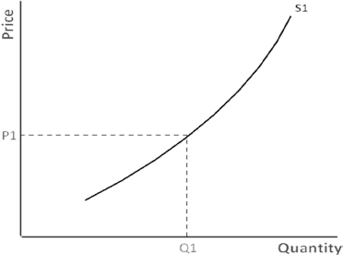
What changes: S or Q_{s}?

- There is a new invention that makes hot chocolate in an automatic processor that adds marshmallow whipped cream that is extremely efficient and cost effective. What happens in the manufacturers market?

Hot Chocolate Graph:

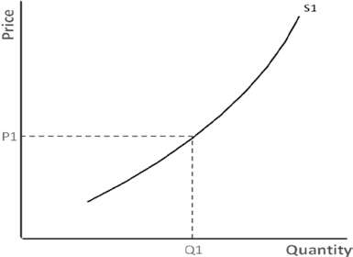
What changes: S or Q_{s}?

- A new producer of cookies enters the industry. What happens in the market for cookies?

Cookies Graph:
What changes: S or Q_{s}?

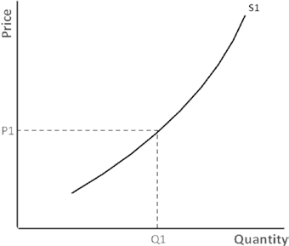
- Brownie producers expect the cost of their raw materials to increase in 4 months. What happens in the market for the supplier today?

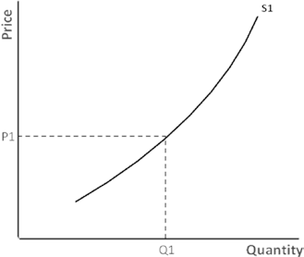
Brownies Graph:
What changes: S or Q_{s}?

- The price of the ice cream cone sold by the ice cream truck goes up 10 cents a cone. What happens in this market from the suppliers’ point of view?

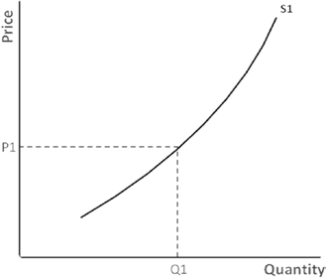
Ice Cream Cones Graph:
What changes: S or Q_{s}?

Market Changes in Supply Answer Key

Practice your graph skills with this worksheet. You will be given several different scenarios that occur to a market that was in equilibrium before this scenario occurred.
- Graph the new situation so that it shows the change that occurred.
- Circle where indicated whether there has been a change in supply, or a change in quantity supplied.
- Be sure to show the new equilibrium price and quantity points on your graph.
- Explain the reason for the change.

Here are your scenarios:
- The cost of the eggs and milk used to make cakes at the local bakery increases. What happens in the bakery market for cake?

Cake Graph:
What changes: S or Q_{s}? S

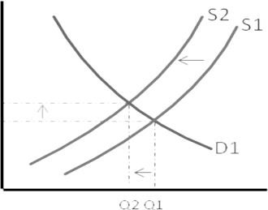
1d. Since cost of input prices rise, supply will decrease for cake.

- There is a new invention that makes hot chocolate in an automatic processor that adds marshmallow whipped cream that is extremely efficient and cost effective. What happens in the manufacturers market?

Hot Chocolate Graph:
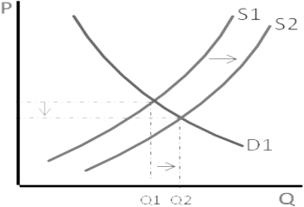
What changes: S or Q_{s}? S 2d. Due to technical
improvement, costs decrease so supply increases

- A new producer of cookies enters the industry. What happens in the market for cookies?

Cookies Graph:

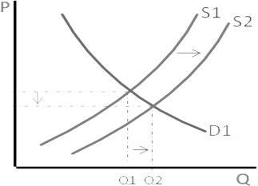
What changes: S or Q_{s}? S

3d. When more suppliers enter the cookie industry, the supply increases for cookies.

- Brownie producers expect the cost of their raw materials to increase in 4 months. What happens in the market for the supplier today?

Brownies Graph:

What changes: S or Q_{s}? S

4d. Since input costs are projected to rise in the future, suppliers will provide more brownies now at a cheaper cost.

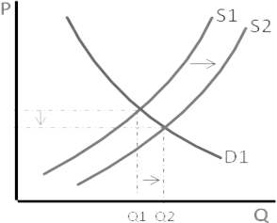
- The price of the ice cream cone sold by the ice cream truck goes up 10 cents a cone. What happens in this market from the suppliers’ point of view?

Ice Cream Cones Graph:

What changes: S or Q_{s}? Q_{s}

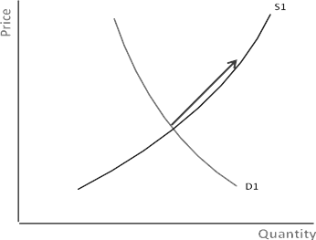
5d. When the price of ice cream cones rises, there will be an increase in quantity supplied of ice cream con

