Monetary Policy

Use the back of the paper to answer these questions and draw the graphs:

- Suppose the economy is currently suffering from a very high rate of inflation caused by aggregate demand that has increased beyond potential GDP.
  - In a correctly labeled graph, show equilibrium in the money market.
  - In a correctly labeled AD/AS graph, show the current short-run equilibrium in the macroeconomy.
  - In response to this high inflation rate, what open market operation should the Fed undertake?

  - In your graph from part (a), show the impact of this monetary policy in the money market and on the equilibrium interest rate.
  - In your graph from part (b), show the impact of this monetary policy on real GDP and the price level.
  - Explain how the open-market operation impacted output and price level.

- Suppose the economy is currently suffering from a very high rate of unemployment caused by a decrease in consumer confidence in the economy.
  - In a correctly labeled graph, show equilibrium in the money market.
  - In a correctly labeled AD/AS graph, show the current short-run equilibrium in the macroeconomy.
  - What monetary policy tool could the Fed undertake to correct the problem?

  - In your graph from part (a), show the impact of this monetary policy in the money market and on the equilibrium interest rate.
  - In your graph from part (b), show the impact of this monetary policy on real GDP and the price level.
  - Explain how the open-market operation impacted output and price level.

Monetary Policy Answer Key
- Suppose the economy is currently suffering from a very high rate of inflation caused by aggregate demand that has increased beyond potential GDP.
  - In a correctly labeled graph, show equilibrium in the money market.
  - In a correctly labeled AD/AS graph, show the current short-run equilibrium in the macroeconomy.
  - In response to this high inflation rate, what open market operation should the Fed undertake?
  - In your graph from part (a), show the impact of this monetary policy in the money market and on the equilibrium interest rate.
  - In your graph from part (b), show the impact of this monetary policy on real GDP and the price level.
  - Explain how the open-market operation impacted output and price level.
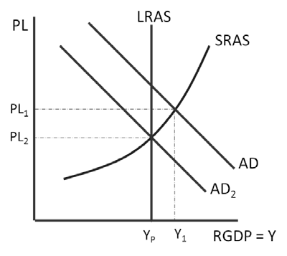
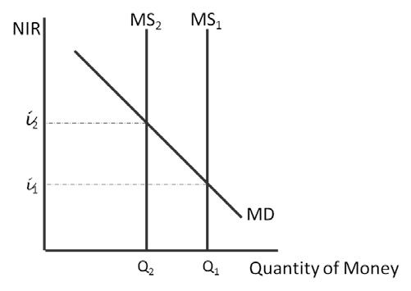

c. Sell government bonds

f. The open market sale will decrease the money supply, increase interest rates, decrease investment and consumer spending, decrease aggregate demand, and decrease output and price level.

- Suppose the economy is currently suffering from a very high rate of unemployment caused by a decrease in consumer confidence in the economy.
  - In a correctly labeled graph, show equilibrium in the money market.
  - In a correctly labeled AD/AS graph, show the current short-run equilibrium in the macroeconomy.
  - What monetary policy tool could the Fed undertake to correct the problem?
  - In your graph from part (a), show the impact of this monetary policy in the money market and on the equilibrium interest rate.
  - In your graph from part (b), show the impact of this monetary policy on real GDP and the price level.
  - Explain how the open-market operation impacted output and price level.

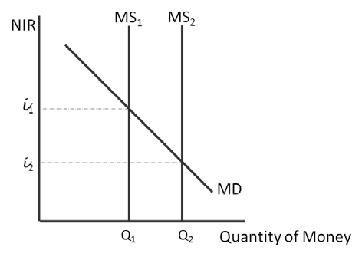
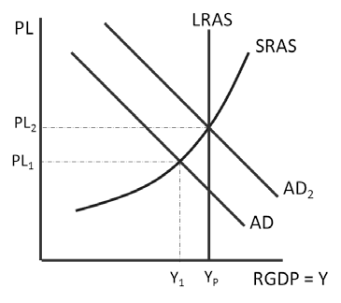

c. Buy government bonds, or decrease the discount rate, or decrease the reserve requirement

f. The policy chosen will increase the money supply, decrease interest rates, increase investment and consumer spending, increase aggregate demand, and increase output and price level.

