Monetary Policy in the Short and Long Run

Fully answer each of the following questions.

- Assume an economy is in long-run equilibrium.
  - Draw a correctly labeled graph of aggregate demand and supply of this economy.
  - Draw a correctly labeled graph of equilibrium in the money market.
  - On your graph in part (b), show what happens to the money market in the short run if the central bank decreases the money supply.
  - On your graph in part (a), show what happens to the macroeconomy in the short run if the central bank decreases the money supply.
  - On both graphs, show what will happen in the long run. Explain these adjustments.

- Assume an economy is in long-run equilibrium.
  - Draw a correctly labeled graph of aggregate demand and supply of this economy.
  - Draw a correctly labeled graph of equilibrium in the money market.
  - On your graph in part (b), show what happens to the money market in the short run if the central bank increases the money supply.
  - On your graph in part (a), show what happens to the macroeconomy in the short run if the central bank increases the money supply.
  - On both graphs, show what will happen in the long run. Explain these adjustments.

Monetary Policy in the Short and Long Run Answer Key
Fully answer each of the following questions.

- Assume an economy is in long-run equilibrium.
  - Draw a correctly labeled graph of aggregate demand and supply of this economy.
  - Draw a correctly labeled graph of equilibrium in the money market.
  - On your graph in part (b), show what happens to the money market in the short run if the central bank decreases the money supply.
  - On your graph in part (a), show what happens to the macroeconomy in the short run if the central bank decreases the money supply.
  - On both graphs, show what will happen in the long run. Explain these adjustments.
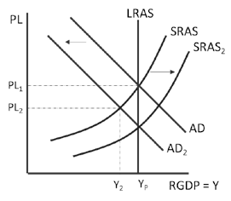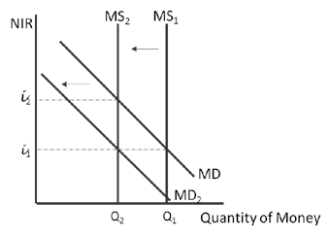
e. In the long run, the decrease in wages will decrease the costs of production increasing short- run aggregate supply to the original potential output at a lower price level (AD₂–SRAS₂). In addition, lower prices lead to less demand for money, decreasing the nominal interest rate to its original level.

- Assume an economy is in long-run equilibrium.
  - Draw a correctly labeled graph of aggregate demand and supply of this economy.
  - Draw a correctly labeled graph of equilibrium in the money market.
  - On your graph in part (b), show what happens to the money market in the short run if the central bank increases the money supply.
  - On your graph in part (a), show what happens to the macroeconomy in the short run if the central bank increases the money supply.
  - On both graphs, show what will happen in the long run. Explain these adjustments.
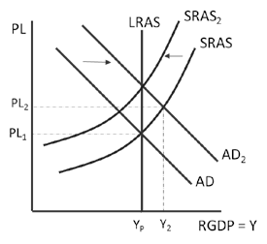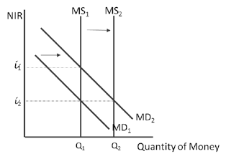
- In the long run, the increase in wages will increase the costs of production decreasing short- run aggregate supply to the original potential output at a higher price level (AD₂–SRAS₂). In addition, higher prices lead to more demand for money, increasing the nominal interest rate to its original level.

