Origins and Function of Government
Warm-up: What would life be like without government?

Activity #1: Look at the pictures and write what function of government the picture represents.
- _________________________________________
- _________________________________________
- _________________________________________
- _________________________________________
- _________________________________________
- _________________________________________
Activity #2: Use the graphic organizer below to copy the notes from the board.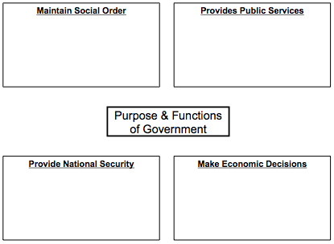
Activity #3: Which of these functions do you feel is most important and why? Provide an answer and reasons.
________________________________________________________________________________________
________________________________________________________________________________________
________________________________________________________________________________________
________________________________________________________________________________________
Activity #4: Use the graphic organizer below to copy the notes from the board.
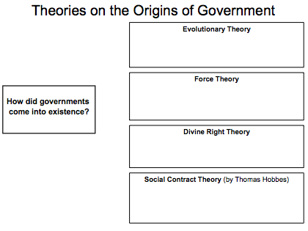
Activity #5: Watch Crash Course U.S. Government and take notes below. Be sure to write his definition of Government.
________________________________________________________________________________________
________________________________________________________________________________________
________________________________________________________________________________________
________________________________________________________________________________________ ________________________________________________________________________________________
________________________________________________________________________________________
________________________________________________________________________________________

