Production Possibilities Curves
Using the given production possibility curve as a starting point, correctly label the graph and show the result of each of the following.

There is an increase in unemployment in a nation using all of its resources and producing 20 boats (Horizontal) and 0 cheese balls (Vertical) or 60 cheese balls and 0 boats.

There is a decrease in technology in a nation using all of its resources and producing 100 kites (V) and 0 bales of hay (H) or 25 bales of hay and 0 kites.

Suppose a nation using all of its resources can produce 20 computers
- and 0 bottles of salad dressing
- or 80 bottles of salad dressing and 0 computers. The nation is currently producing 10 computers and 40 bottles of dressing (Label as point A). The residents express a desire to have more computers.

A blight destroys 80% of the potato crop in a nation using all of its resources and producing 400 bolts
(H) and 0 bags of potato chips (V) or 600 bags of potato chips and 0 bolts.

There is an increase in population in a nation using all of its resources and producing 100 t-shirts (V) and 0 baseballs (H) or 100 baseballs and 0
t-shirts.

There is an increase in capital investment in a nation using all of its resources and producing 500 candy bars (V) and 0 trucks (H) or 30 trucks and 0 candy bars.

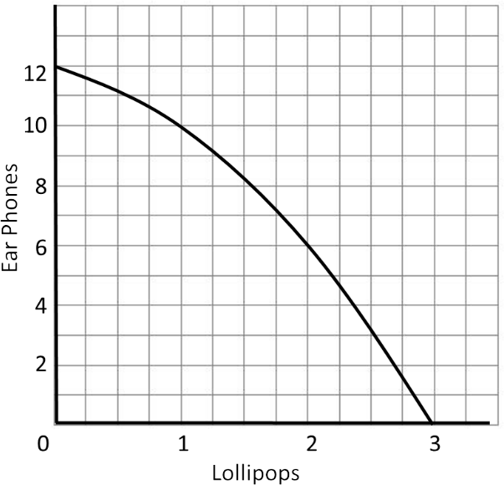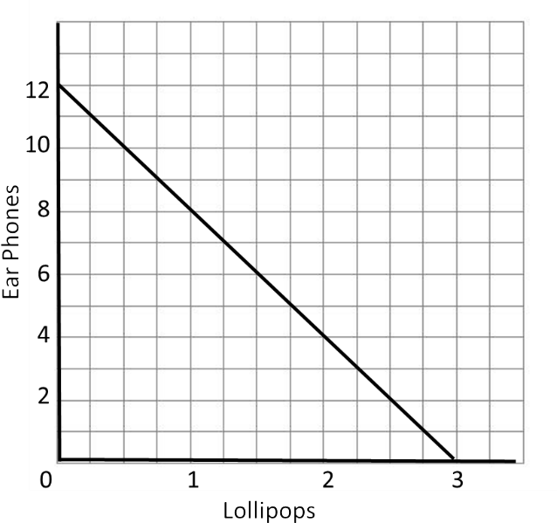

Nation A Nation B

Nation A and B can each produce Lollipops and Ear Phones. Assume each nation is producing 12 units of ear phones and 0 units of lollipops.
- What is the opportunity cost for each nation to increase production from 0 lollipops to 1 lollipop?

Nation A Nation B

- What is the opportunity cost for each nation to increase production from 1 lollipop to 2 lollipops?

Nation A Nation B

- What is the opportunity cost for each nation to increase production from 2 lollipops to 3 lollipops?

Nation A Nation B

- What can you deduce about the costs of production in each nation? Explain.

Production Possibilities Curves Answer Key
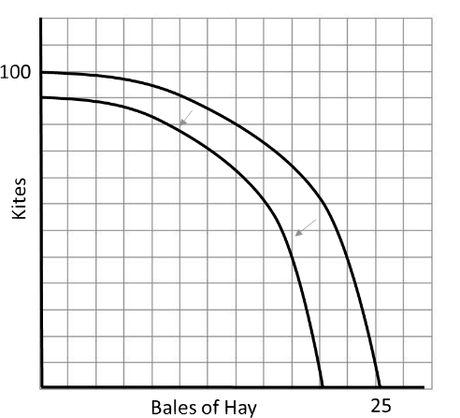
Using the given production possibility curve as a starting point, correctly label the graph and show the result of each of the following.

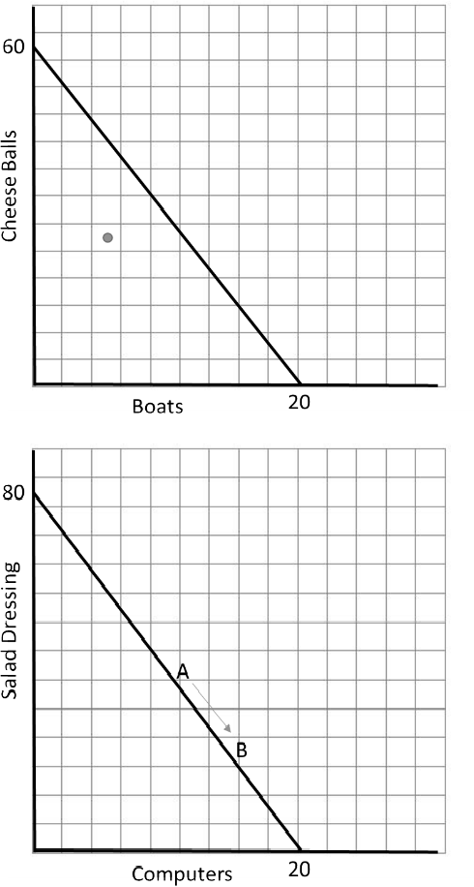
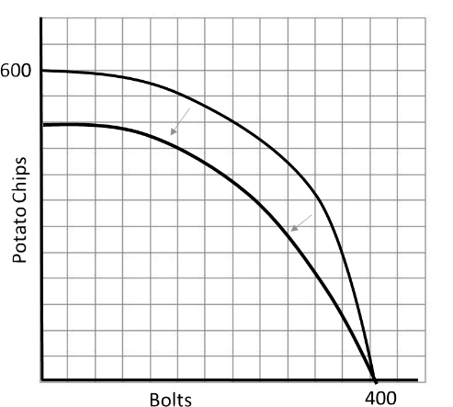
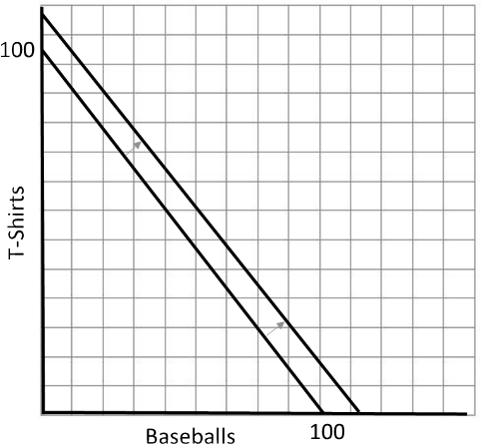
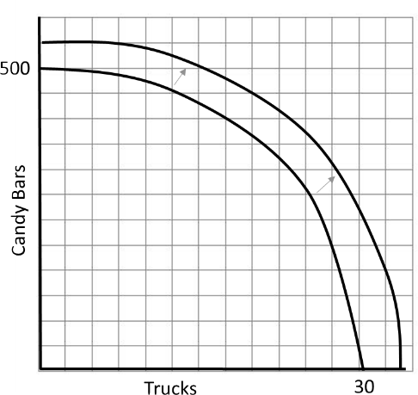

Nation A Nation B

Nation A and B can each produce Lollipops and Ear Phones. Assume each nation is producing 12 units of ear phones and 0 units of lollipops.
- What is the opportunity cost for each nation to increase production from 0 lollipops to 1 lollipop?

Nation A 2 Nation B 4

- What is the opportunity cost for each nation to increase production from 1 lollipop to 2 lollipops?

Nation A 4 Nation B 4

- What is the opportunity cost for each nation to increase production from 2 lollipops to 3 lollipops?

Nation A 6 Nation B 4

- What can you deduce about the costs of production in each nation? Explain.
Nation A has increasing production costs because as lollipop production increases, increasing amounts of ear phones must be given up.
Nation B has constant production costs because as lollipop production increases, the same amount of ear phones must be given up

