Supply-Side Economics

Answer the following questions regarding supply-side economics.

Draw a correctly labeled AD/AS graph in equilibrium using the outline provided.

Using the graph you drew in part 1, show and explain the impact of inflationary expectations on the economy. What happens to output, price level, and employment?

Using the new graph outline below, draw an inflationary gap. Show and explain how a supply- side economist would correct the problem.

-Side Economics Answer Key

Draw a correctly labeled AD/AS graph in equilibrium using the outline provided.

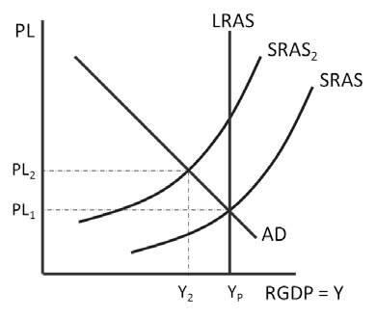

Using the graph you drew in part 1, show and explain the impact of inflationary expectations on the economy. What happens to output, price level, and employment?

The inflationary expectations would decrease aggregate supply, causing stagflation. Output and employment decrease while price level increases.

Using the new graph outline below, draw an inflationary gap. Show and explain how a supply- side economist would correct the problem.

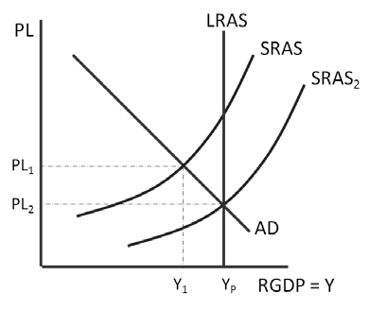
A supply-side economist would decrease business taxes, shifting SRAS to the right. This would increase output and decrease price level.

