Tax and Transfer Multiplier

Answer the following questions to demonstrate your understanding of the spending multiplier.

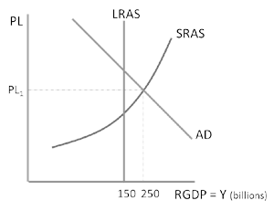
1. A recessionary gap of $40 billion is present in the economy and MPC is 0.75. How could Congress close the tax using a change in taxes?
The government wants to use a change in taxes to close the gap in the economy. MPC is 0.8.
- How large is the gap?
- What is the amount and direction
- (increase/decrease) of the change in taxes
needed to close the gap?

2.

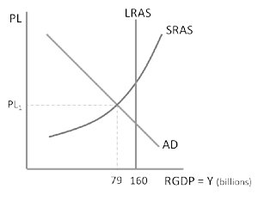
3.
The government wants to use a change in transfer payments to close the gap in the economy. MPC is 0.9.
- How large is the gap?
- What is the amount and direction (increase/decrease) of the change in transfer needed to close the gap?

4. Create a table showing the tax and transfer multiplier for each of the MPCs listed.

MPC | Tax/Transfer Multiplier
0.5
0.75
0.8
0.9

Tax and Transfer Multiplier Answer Key

Answer the following questions to demonstrate your understanding of the spending multiplier.

1. A recessionary gap of $40 billion is present in the economy and MPC is 0.75. How could Congress close the tax using a change in taxes?

𝑀𝑃𝐶 = ^{.75} = 3; ^{$40} = $13.3 billion decrease in taxes.
𝑀𝑃𝑆 .25 3
The government wants to use a change in taxes to close the gap in the economy. MPC is 0.8.
- How large is the gap?
- What is the amount and direction (increase/decrease) of the change in taxes needed to close the gap?

2.
•

The gap is $250b - $150b = $100 billion
𝑀𝑃𝐶 = ^{.8} = 4; ^{$100} = $25 billion decrease in taxes.
𝑀𝑃𝑆 .2 4

3.
The government wants to use a change in transfer payments to close the gap in the economy. MPC is 0.9.
- How large is the gap?
- What is the amount and direction (increase/decrease) of the change in transfer needed to close the gap?

The gap is $160b - $79b = $81 billion
𝑀𝑃𝐶 = ^{.9} = 4; ^{$81} = $9 billion increase in transfer payments.
𝑀𝑃𝑆 .1 9

4. Create a table showing the tax and transfer multiplier for each of the MPCs listed.

MPC | Tax/Transfer Multiplier
0.5 | 1
0.75 | 3
0.8 | 4
0.9 | 9

