The Macro Analysis Framework

Using this question, set up the four components of macroeconomic analysis: Assume that the United States economy is in a long-run equilibrium.
- Draw a correctly labeled long run graph of aggregate demand and aggregate supply and
show each of the following for the United States.
  - The current equilibrium output level, labeled Y_{A}, and the current equilibrium price level, labeled PL_{e}.
- Suppose that consumer confidence in the United States experiences a significant downturn. In the graph drawn in part (a), show the impact of weakened consumer confidence. In the graph, show any changes to the equilibrium price level and the equilibrium output level.
- Assume that the central bank of the United States is prepared to take action to reverse the economic impacts shown in part (b).
  - Should the central bank buy or sell bonds in an open market operation?
  - How does the central bank’s action in part (c)(i) affect the nominal interest rate? Explain.
- The United States and Mexico are major trading partners. How would the monetary policy in the United States affect the balance of payments current account with Mexico? Explain.

- What is the starting point?

- What is the pivotal event?

- What are the initial effects of the event?

- What are secondary and long-run effects of the event?

The Macro Analysis Framework Answer Key

Note that there are teacher notes embedded in this answer key so that the teacher can review the concepts of each given point.
- The Starting Point:
Equilibrium output is currently at full-employment output is the starting point.
Note:
Every question such as this gives the student a starting point. The student must demonstrate that he/she can understand, and usually graph, the situation that is given. In this case, the economy is in long run equilibrium. If necessary, review the implications of long-run equilibrium in the AD/AS model. The student must be aware that, given this starting point, there is neither an inflationary nor a recessionary gap.
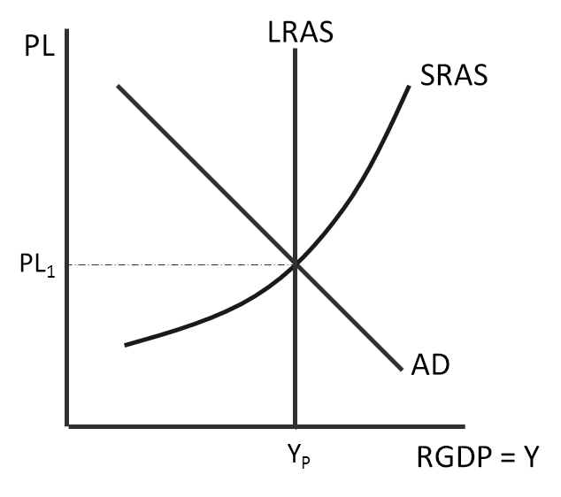
1 point: A correctly labeled graph with the AD, SRAS, and LRAS curves all intersecting. 1 point: The equilibrium output level is shown at LRAS.
1 point: The equilibrium price level is shown at the intersection of AD and SRAS.

- The Pivotal Event
Consumer confidence has significantly is the pivotal event. Consumer confidence is a factor of aggregate demand. Aggregate demand will decrease.
Note:
Students should know the factors that shift AD, SRAS, and LRAS and that weaker consumer confidence causes a decrease in AD. This is a great opportunity to review all of these “shifters” in the AD/AS model.

1 point: For recognizing that a lower level of consumer confidence will decrease aggregate demand.

- The initial events of the event
The graph shows the leftward shift of the aggregate demand curve. As a result of this shift, price level has fallen to PL₂ and real GDP has decreased to Y₁.
Note:
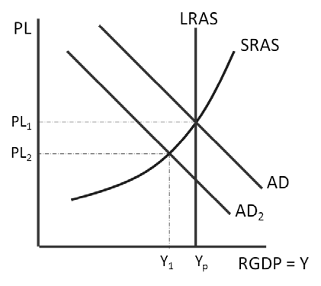
Take time to review recessional gap and inflationary gap concepts. The secondary effects will be the result of action to take to counteract this recessional gap.
1 point: The graph shows a leftward shift of the AD curve.
1 point: The graph indicates a decrease in both the price level and real GDP.

- Secondary and Long-Run Effects
  - The central bank, given the weakened demand shown in part (b), should be pursuing expansionary monetary policy. The FED will buy bonds. This increases the money supply, which causes the nominal rate of interest to decrease.
Note:
Take time to review the tools of the Fed. In the case of this question, the student is asked to focus on open market operations. To expand the money supply, the central bank should buy bonds.

1 point: Buy bonds
The student who understands monetary policy in the face of a recessionary gap also knows why buying bonds is the correct policy prescription.
1 point: The nominal interest rate decreases.
1 point: Buying bonds shifts the money supply curve to the right. In the money market, this causes the nominal interest rate to fall.

  - The current account on the balance of payments account will fall since the action of the FED to lower interest rates will depreciate the value of the dollar against the Mexican peso. Products flowing from US to Mexico are relatively cheaper so more export sale are higher.

Note:
This part of the problem tests the student’s understanding of the balance of payments accounts and how international business cycles begin to affect the international flow of goods and money. Note that the question is directed to focus on the monetary policy action not the recession caused of the lower consumer confidence.

1 point: The current account balance in the U.S. will begin to fall.
1 point: Exports will rise as more goods flow to Mexico so current account of the balance of payments account falls.

