The Market for Loanable Funds

For each of the following scenarios, use a correctly labeled graph to show how the market for loanable funds is affected. Show in your graph the impact on the equilibrium interest rate and quantity of loanable funds. Draw your graphs in the space below the questions.
- The Chair of the Federal Reserve testifies before Congress that he/she expects the health of the economy to significantly improve in coming months.

- Households fear an imminent recession and begin to cut back on discretionary purchases.

- The Federal government announces another annual budget surplus.

- The flow of foreign financial capital into American financial markets begins to decrease.

Congress uses expansionary fiscal policy but does not change the tax rates.

The Market for Loanable Funds Answer Key

For each of the following scenarios, use a correctly labeled graph to show how the market for loanable funds is affected. Show in your graph the impact on the equilibrium interest rate and quantity of loanable funds.
- The Chair of the Federal Reserve testifies before Congress that he/she expects the health of the economy to significantly improve in coming months.
- Households fear an imminent recession and begin to cut back on discretionary purchases.
- The Federal government announces another annual budget surplus.
- The flow of foreign financial capital into American financial markets begins to decrease.

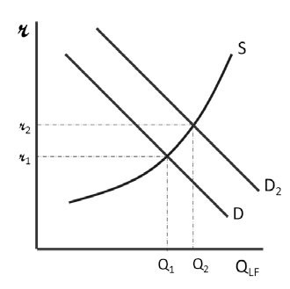
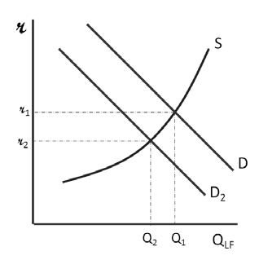
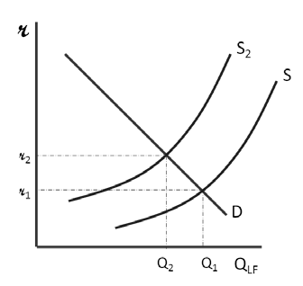
Congress uses expansionary fiscal policy but does not change the tax rates.
2.
4.

1.

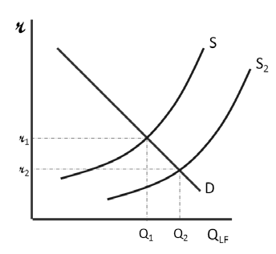
3.

5.

