The Phillips Curve

Set up a correctly labeled Phillips Curve graph to begin each scenario.
Then, show and explain below what happens to the short-run Phillips curve. Assume the natural rate of unemployment is 5%. When showing a movement along the curve, label the initial point, A, and the new point, B. Use standard notation when shifting the curve.

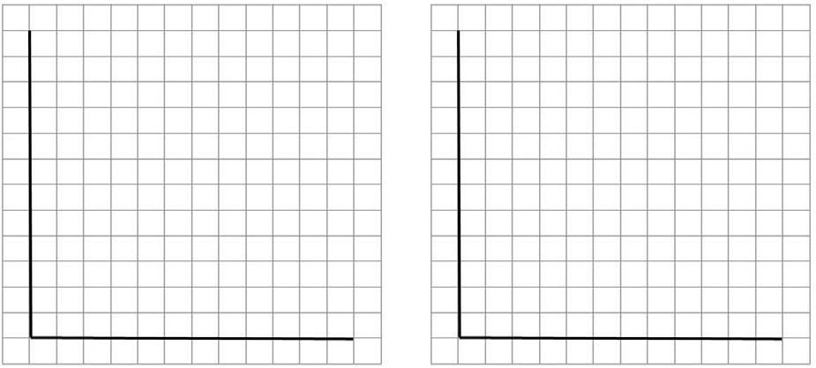
Government spending increases. The price of crude oil and most
sources of energy decreases.

Inflation expectations rise from 3% to 6%. The Fed increases interest rates with
contractionary monetary policy.

Inflation expectations fall from 5% to 2%. The government increases income taxes.

Tornados strike the South and Midwest Consumer confidence falls amid news of destroying much of the nations political squabbling.
manufacturing ability.

The Phillips Curve Answer Key

Set up a correctly labeled Phillips Curve graph to begin each scenario.
Then, show and explain below what happens to the short-run Phillips curve. Assume the natural rate of unemployment is 5%. When showing a movement along the curve, label the initial point, A, and the new point, B. Use standard notation when shifting the curve.
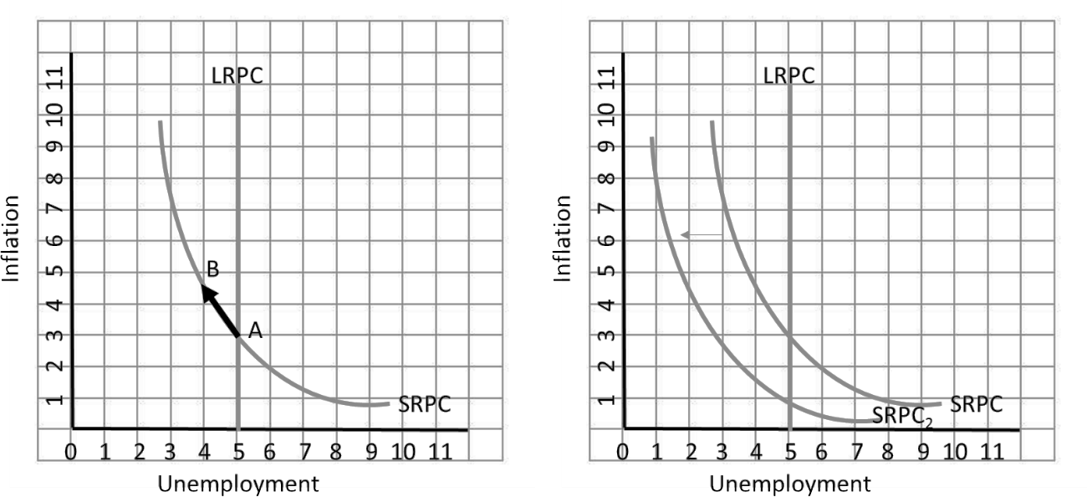

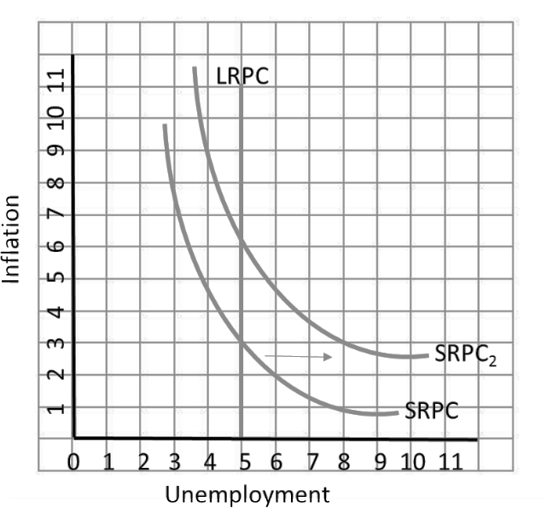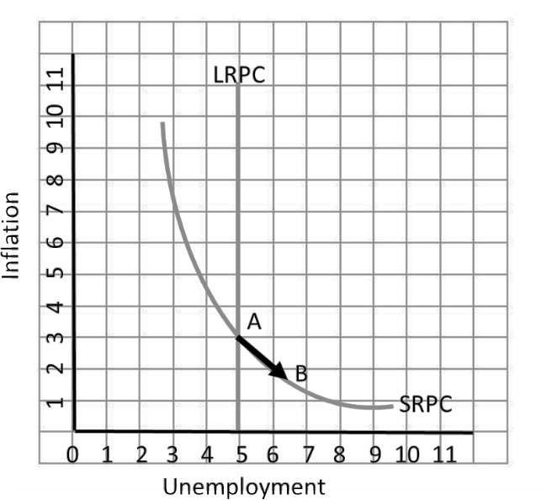
Government spending increases. AD shifts right, increasing inflation and decreasing unemployment
The price of crude oil and most sources of energy decreases.
SRAS shifts right, decreasing inflation and unemployment
Inflation expectations rise from 3% to 6%.
SRAS shifts left, increasing inflation and unemployment
The Fed increases interest rates with contractionary monetary policy.
AD shifts left, decreasing inflation and increasing unemployment

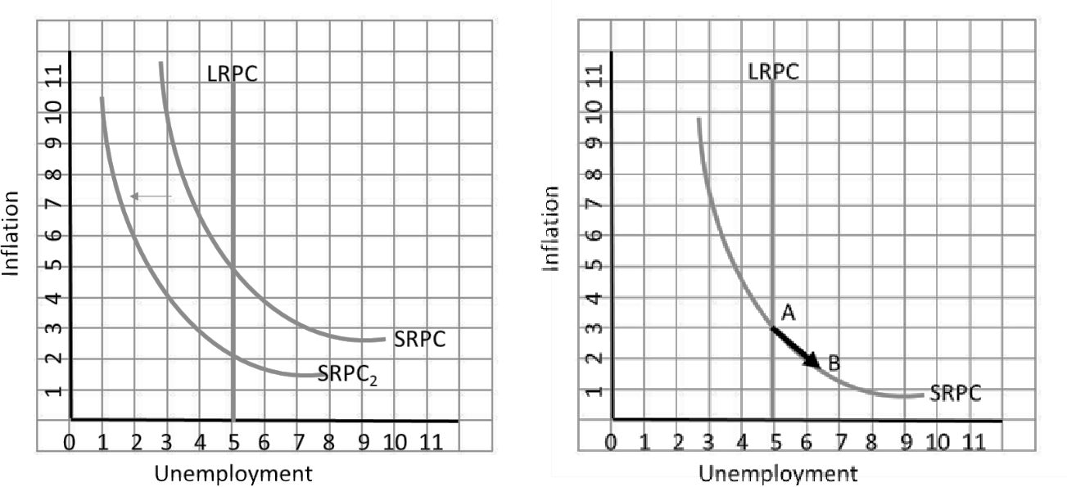
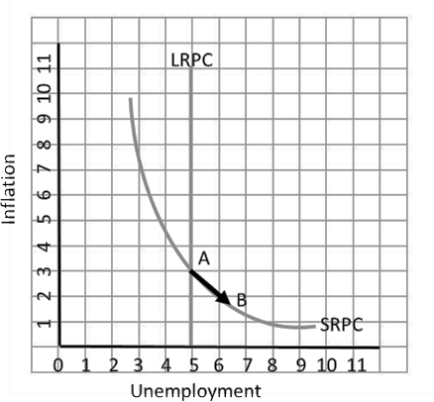
Inflation expectations fall from 5% to 2%. SRAS shifts right, decreasing inflation and unemployment
The government increases income taxes.
AD shifts left, decreasing inflation and increasing unemployment

Tornados strike the South and Midwest destroying much of the nation’s manufacturing ability. SRAS shifts left, increasing inflation and unemployment
Consumer confidence falls amid news of political squabbling.
AD shifts left, decreasing inflation and increasing unemployment

