Trade Barriers

Answer the following questions.

- Show on a correctly labeled graph and explain what will happen in the market for wood if the
U.S. places a tariff on foreign wood.
Explanation

- Show on a correctly labeled graph and explain how the tariffs on foreign goods would impact the international value of the U.S. dollar.
Explanation

- Suppose instead that the United States imposes a quota on wood. Show on a correctly labeled graph how the market for wood will be impacted.

- Who are the winners and losers when tariffs are imposed on foreign goods?

Barriers Answer Key

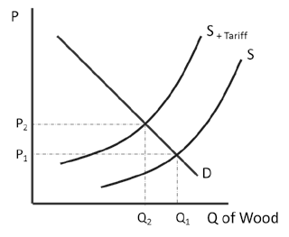
Show and explain what will happen in the market for wood if the U.S. places a tariff on foreign wood.

Supply shifts left as some producers are not willing or able to pay the tariff increasing price and decreasing quantity.

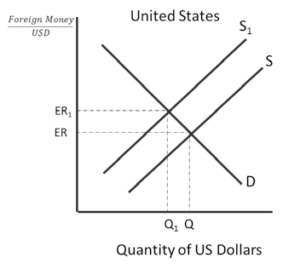
- Show and explain how the tariffs on foreign goods would impact the international value of the U.S. dollar.

Because foreign wood is more expensive, there is a decrease in supply of U.S. dollars to the foreign exchange market.
This causes the U.S. dollar to appreciate.

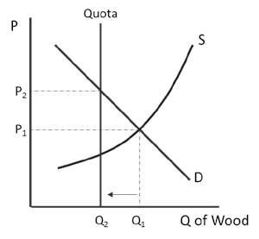
- Suppose instead that the United States imposes a quota on wood. Show how the market for wood will be impacted.

- Who are the winners and losers when tariffs are imposed on foreign goods?
Consumers and foreign producers are losers. The U.S. government and domestic producers are winners.

