Monarchy
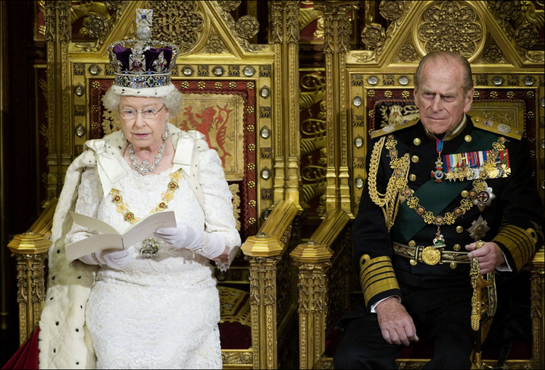
Elizabeth, Queen of England and Prince Philip, Duke of Edinburgh
Definition: A form of government with a single king or queen (monarch) at the head.
Modern/Historical Example: England has had the same monarchy since 1066 AD when William the Conqueror took the throne.
Positives: Eliminates elections, which can be expensive, monarchs rule for life, and can be efficient.
Negatives: Eliminates elections, which takes the voice away from the people, and kings and queens will serve for life whether they deserve to or not.

Military Junta
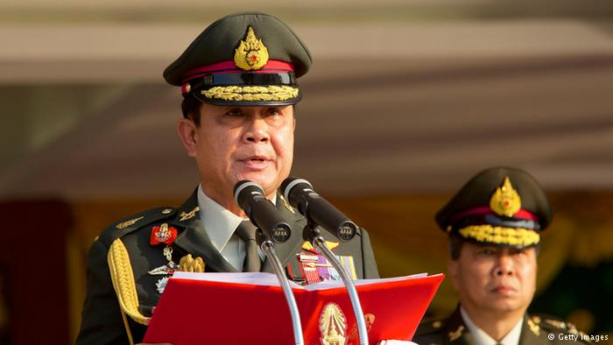
General Gen. Prayuth Chan-ocha, Commander in Chief of the Royal Thai Army
Definition: A group of military officers who rule a country after seizing power.
Modern/Historical Example: In 2014, the Royal Thai Armed Forces, led by Prayut Chan-o-cha, overthrew the government and took over.
Positives: Strong military and discipline. Also, promotes a neutral party.
Negatives: Takes away many rights of the citizens and creates a permanent state of emergency.

Democracy
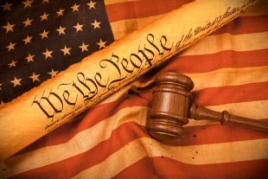
Definition: A form of government in which the supreme authority rests with the people.
Modern/Historical Example: The United States is a Representative Democracy, meaning we vote for individuals that we believe will represent voters in the government.
Positives: Provides consent to the governed and gives the people a voice.
Negatives: Moves slowly and can be inefficient because many parties need to be in relative agreement, which is hard to do.

Dictatorship
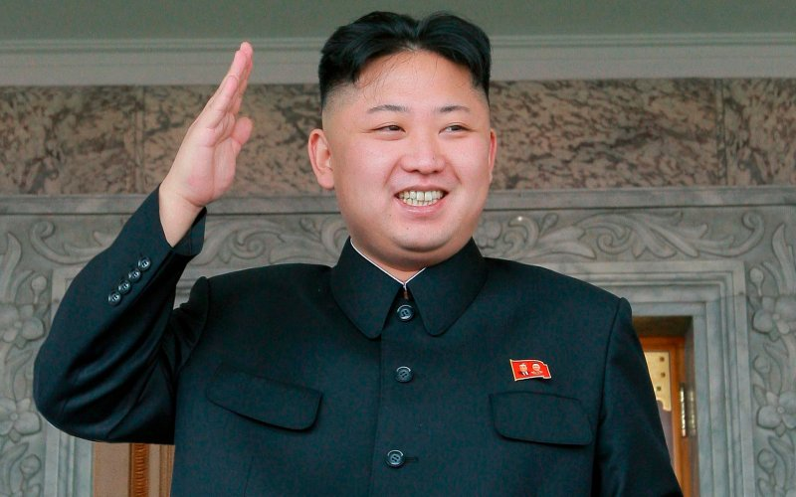
North Korean Dictator Kim Jung Un
Definition: A form of government in which a single leader has the absolute power and authority.
Modern/Historical Example: Adolf Hitler was the dictator in NAZI Germany.
Positives: Incredibly efficient and stable government that results in lower crime rates. No need to seek out agreement from the people or any other groups.
Negatives: Dictatorships lead to abuse in power and, in most cases, violence

Fascism
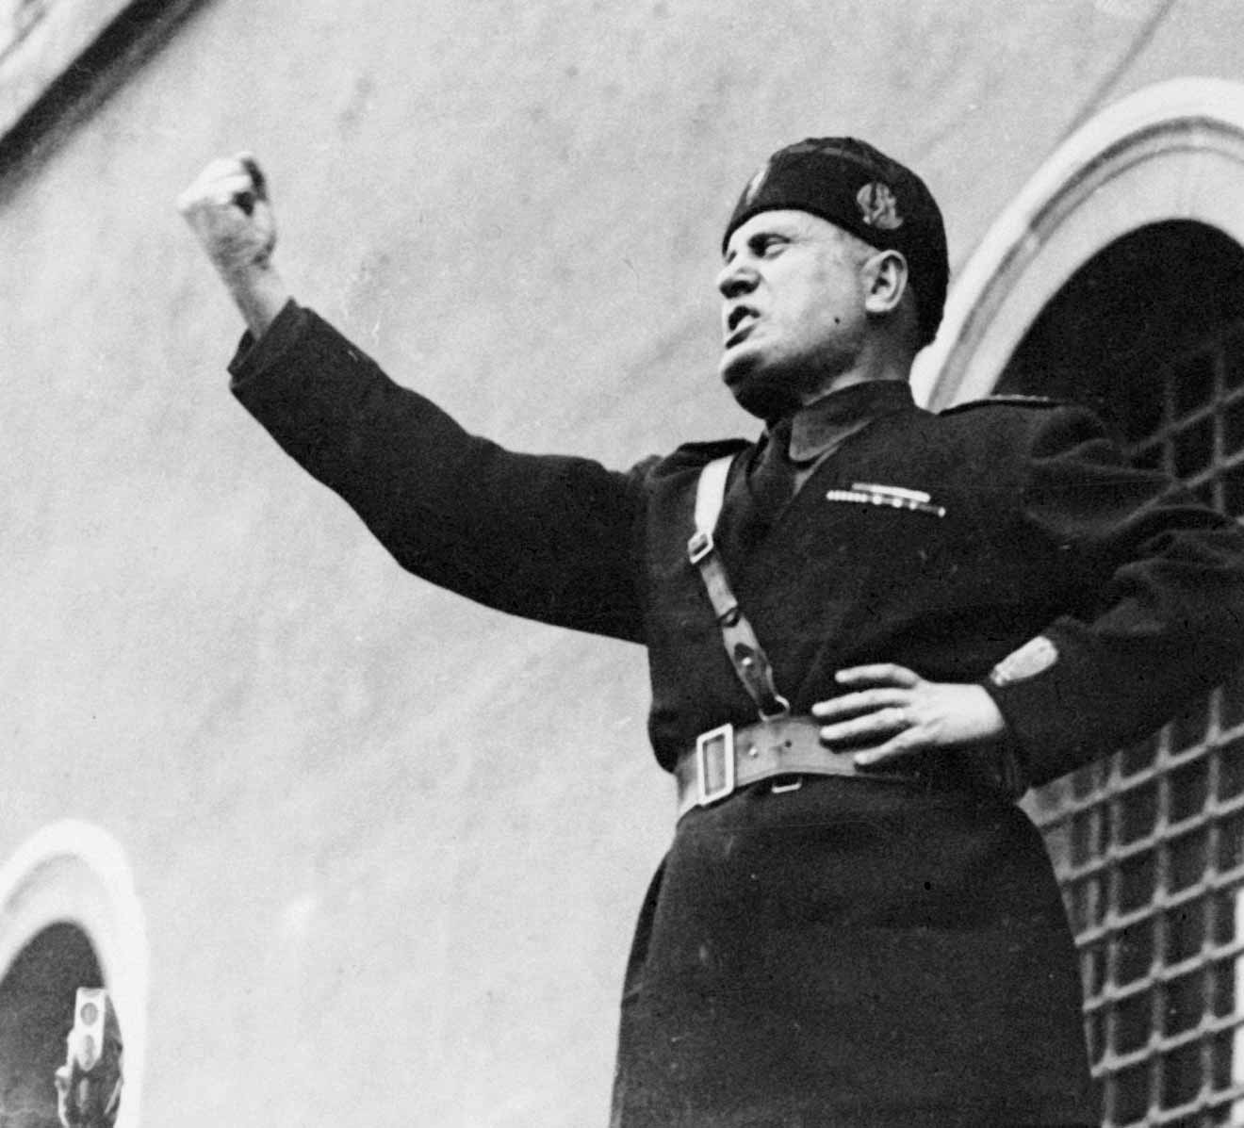
Fascist Italian Dictator Benito Mussolini
Definition: An authoritarian and nationalistic right-wing system of government and social organization.
Modern/Historical Example: World War II Germany and Italy were fascist governments due to their extreme patriotism and focus on military.
Positives: Rise in patriotism and the focus on military results in stronger economy.
Negatives: Promotes discrimination toward minority groups and often leads to xenophobia.

Communism
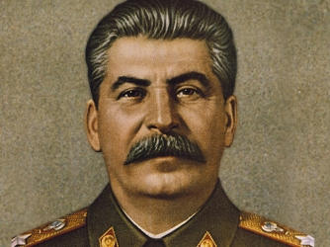
Russian Communist Leader Joseph Stalin
Definition: An ideology which calls for the collective, or state, ownership of land and other productive property.
Modern/Historical Example: Communist Russia, under Joseph Stalin, wanted to create an equal society but was also incredibly violent.
Positives: All members of society are meant to be equal. In principle, this eliminates a world of “haves and have nots”.
Negatives: Does not promote competition or invention because an equal society removes motivation for a “million dollar idea”

Socialism
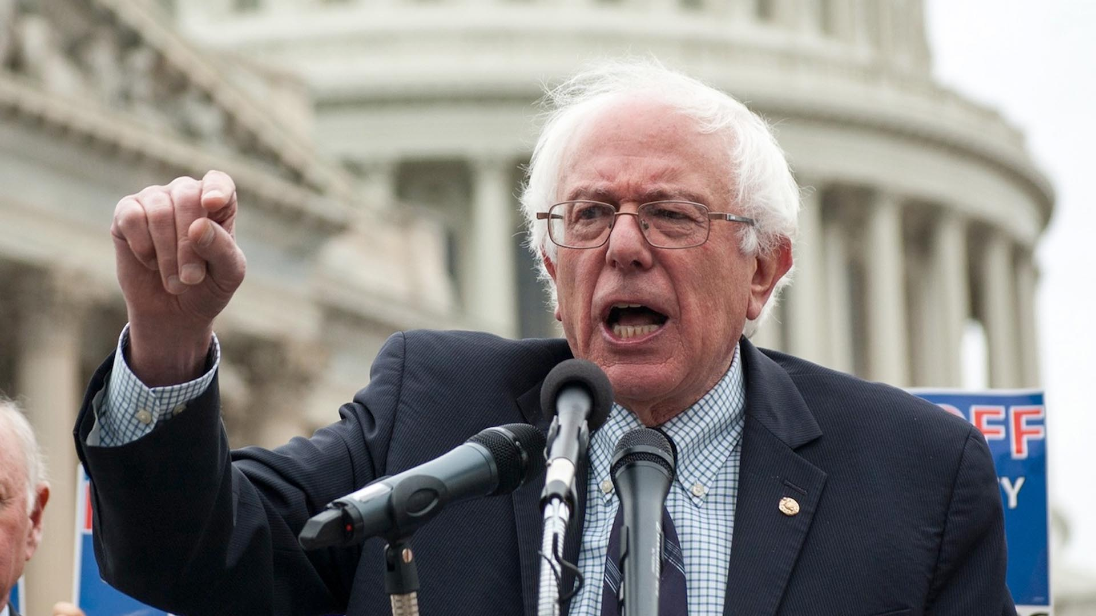
United States Senator Bernie Sanders claims to be a Democratic Socialist
Definition: A philosophy based on the idea that the benefits of economic activity should be fairly distributed.
Modern/Historical Example: Norway, along with other Northern European countries, govern in a socialist democracy. They also are considered the happiest country in the world.
Positives: Very low levels of poverty, which lowers crime, drug use, and suicide rates. Also, creates a strong social safety net for the citizens.
Negatives: Very high taxes, which take away hard earned money, especially among the wealthy.
Theocracy
Turkish President Recep Erdogan is showing tendencies of a Theocracy
Definition: A system of government in which holy people rule in the name of a God or gods.
Modern/Historical Example: Ancient Egypt was a theocracy because they believed the pharaoh ruled with orders from their gods.
Positives: Very few people will question the government if they believe it is coming from a higher power.
Negatives: People do not seek their own solutions because they believe it is against the will of the higher power.

Oligarchy
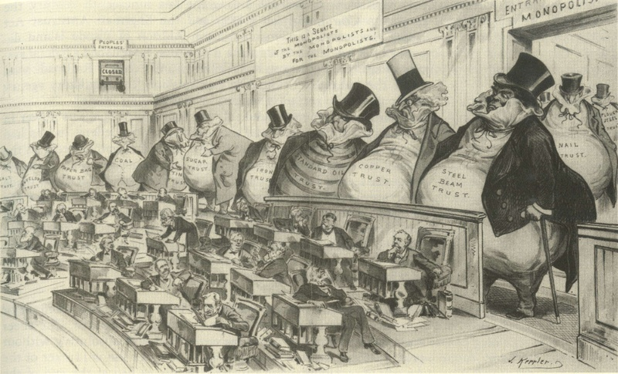
Political Cartoon Describing an “American Oligarchy” of wealthy elite
Definition: A small group of people having control of a country, organization, or institution.
Modern/Historical Example: Since the collapse of the Soviet Union in 1991, privately owned Russia-based billionaires have had heavy influence over the government.
Positives: Big business thrives, which creates a strong national economy.
Negatives: The common man and woman have little opportunity to thrive or improve their social standing.

